Airbnb Project (Sebonti Mahnaz)

Part 1) The Data
Dataset: NYC Airbnb Dataset
Dataset Description
- Id - Listing ID
- name - Listing name
- host_id, host_name - Information about the host
- neighbourhood_group -Location (ex: Manhattan, Brooklyn)
- neighbourhood - More granular neighbourhood area within the location
- latitude, longitude - Geographic coordinates
- room_type - Listing space type
- price - Price per night in USD
- minimum_nights - Minimum required nights per booking
- number_of_reviews - Number of reviews for the listing
- last_review - Date of the last review
- reviews_per_month - Average reviews per month
- calculated_host_listings_count - Amount of listing per host
- availability_365 - Number of days when listing is available for booking
Data Preparation
- Deleted null values in last_review directly in Excel to ensure valid time-series analysis.
- Applied price filter ($10-$2000) across all visualizations to remove invalid entries (e.g.-0) and extreme outliers. This avoided distortion in averages and distributions.
- Defined premium price range as $200-$2000 to highlight luxury demand patterns.
- Grouped minimum nights into categories for clearer analysis:
  - Short Stay: 1-5 nights
  - Medium Stay: 6-30 nights
  - Long Stay: 31+ nights
- Set premium neighbourhoods in Tableau as those with average price > $100, to distinguish luxury areas from mid-market and budget zones.
- Restricted trend line analysis to post-November 2015, since earlier records had no reviews and added noise. This improved clarity and revealed meaningful demand growth.
Analysis and Challenges:
- Initial analysis: Began by cleaning the dataset. Deleted null values in last_review using Excel and applied filters to remove invalid or extreme prices (kept prices from $10-$2000). This ensured the data was reliable before building visualizations.
- Influence on visuals: These cleaning steps guided the choice of charts. For example, filtering prices helped create meaningful price vs. reviews by minimum nights plot and restricting the timeline to post-November 2015 avoided noise in trend lines. Grouping minimum nights into short, medium and long stays also shaped how engagement patterns were visualized.
- Problems faced: Outliers (like $0 or very high prices) and missing dates distorted early results. Without filtering, averages and distributions looked unrealistic. Handling these issues was necessary to make the charts accurate.
- Changes in thinking: As the project progressed, I realized grouping and filtering were essential for storytelling. They revealed clearer market patterns like luxury demand in Manhattan/Brooklyn, steady mid-market strength in Queens and budget niches in Bronx/Staten Island, which ultimately became the backbone of the story.

Part 2) Workbook Sheets
Sheet 1: Listings by Location and Price(Map)
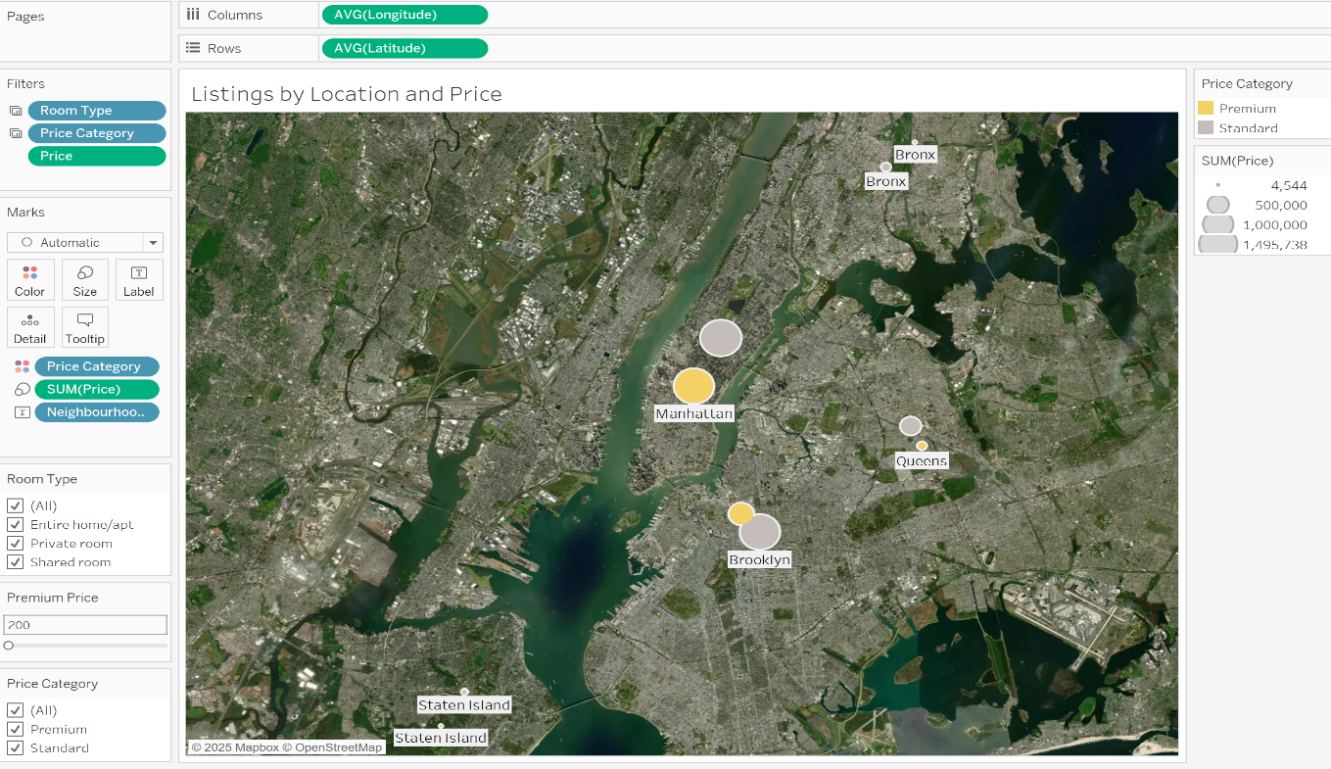
The first worksheet is a map showing Airbnb listings by location and price, with filters for price categories (premium vs. standard) and room types, while the size of each point is determined by price. This visualization revealed clear geographic clustering where premium listings are concentrated in Manhattan and Brooklyn, while more affordable options spread across Queens, Bronx and Staten Island. I chose a map because location and price are the strongest data of Airbnb demand and mapping them together made it possible to see spatial distribution alongside pricing categories. The initial data analysis, which highlighted the importance of filtering prices between $10 and $2000 and defining premium ranges, led directly to this visualization. This analytic is important because it establishes the foundation for understanding market segmentation, showing why certain neighbourhoods dominate luxury demand while others sustain budget niches, and sets the stage for deeper analysis of reviews and engagement in later worksheets.

Sheet 2: Price According to Neighbourhood Groups(Bar Chart)

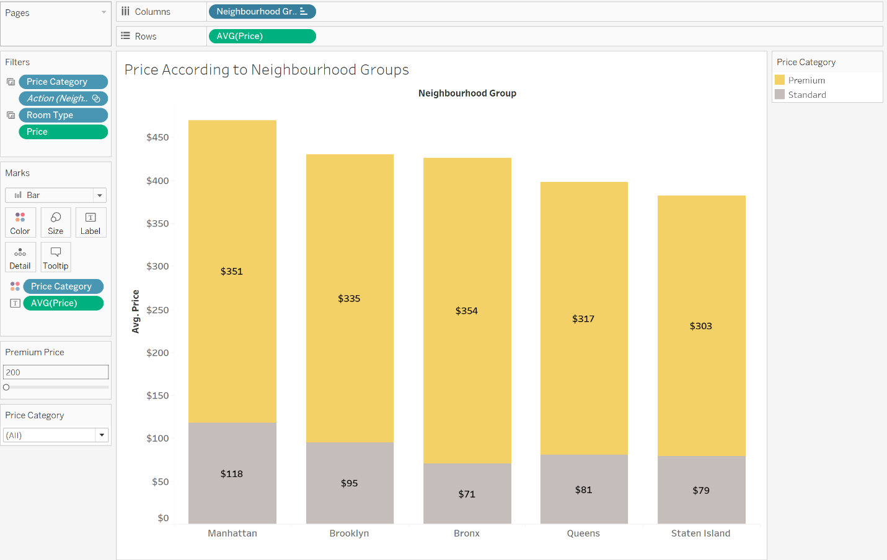

This worksheet presents a bar chart showing the average price of Airbnb listings across neighbourhood groups, with filters for price category and room type. When we adjust the premium price parameter, the visualization highlights that Manhattan and Brooklyn consistently command higher average prices reflecting their premium market status. Meanwhile Queens shows high to mid-range pricing. Bronx and Staten Island remain budget-friendly. I created this chart after the initial data analysis revealed strong price variation by neighbourhoods and I wanted a clear comparison across groups. A bar chart was chosen because it provides a straightforward comparison of averages across categories, making differences easy to interpret. This analytic is meaningful because it connects location with pricing power, helping explain why certain neighbourhoods dominate luxury demand while others sustain affordable niches. It also builds on the geographic insights introduced in first map worksheet.

Sheet 3: Top 3 Neighbourhoods by Metric Selector (Stacked Bar Chart):

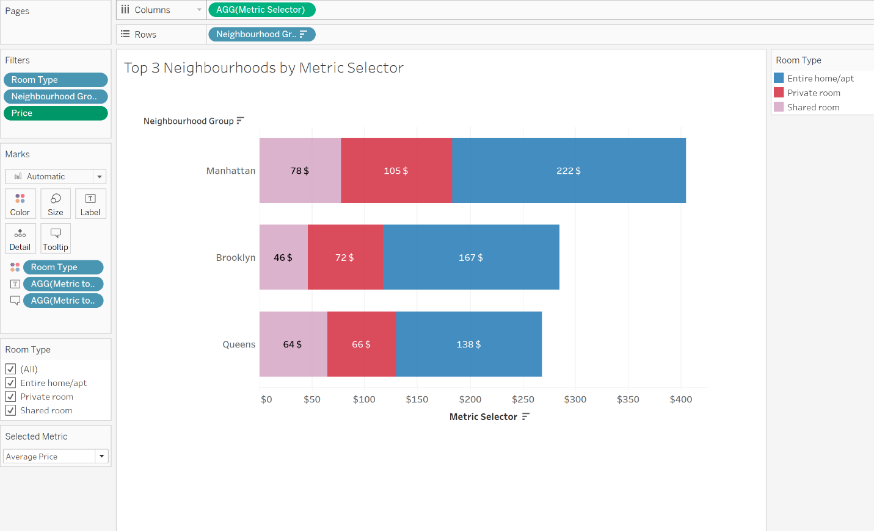

The third worksheet shows the top three neighbourhoods by selected metrics, using interactive selectors for room type, neighbourhood group and price filters. This visualization highlights how different neighbourhoods perform across key measures such as listings, average reviews, average prices, availability etc. It revealed that while Manhattan, Brooklyn and Queens dominate in supply and pricing; Bronx and Staten Island often stand out in reviews and availability, showing guest satisfaction beyond premium markets. I created this view after the initial analysis showed strong variation across neighbourhoods and wanted a flexible way to compare neighbourhoods under different conditions. A selector-based chart was chosen because it allows dynamic comparisons and makes the analysis adaptable to different perspectives. This analytic is meaningful because it uncovers neighbourhood strengths beyond supply, showing how engagement and satisfaction vary; providing a more balanced view of NYC’s Airbnb market.
Sheet 4: Neighbourhood vs. Room Type Comparison (Heat Map)

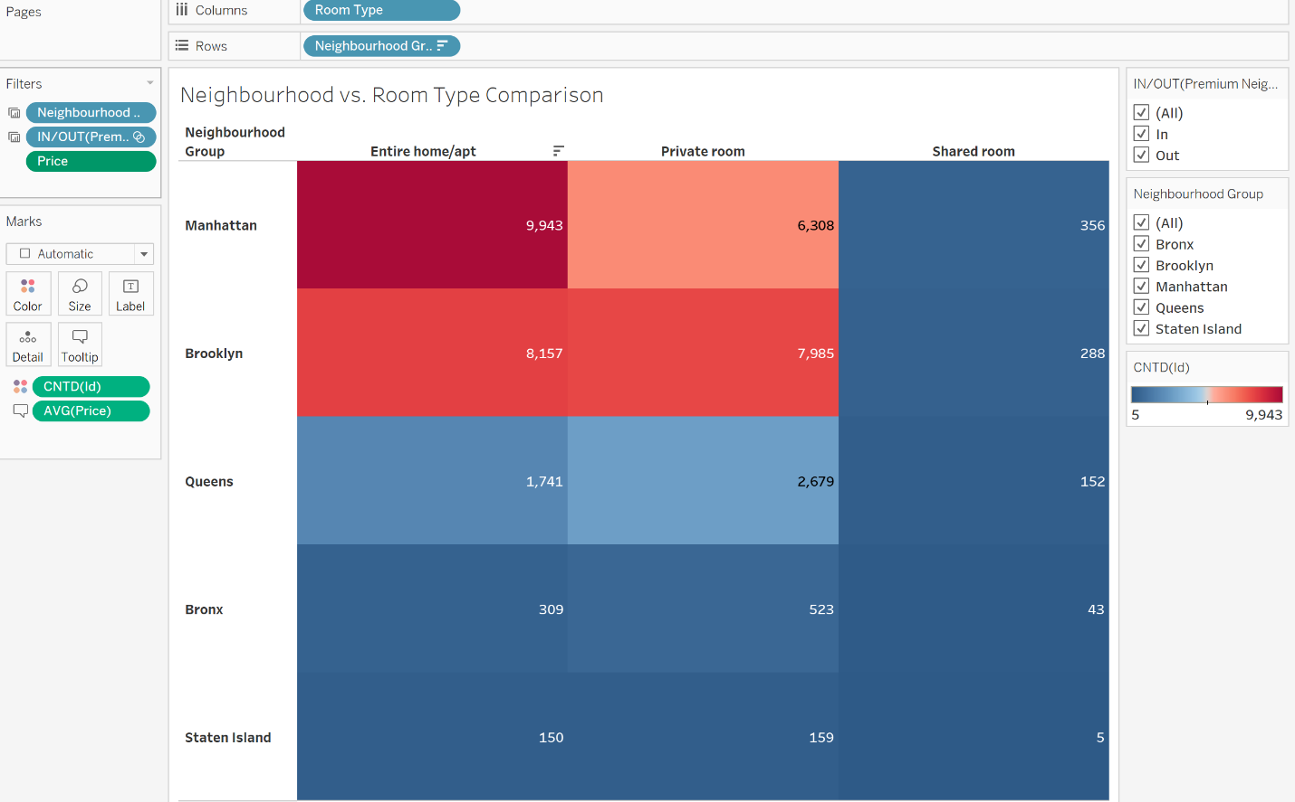

The fourth worksheet compares neighbourhood groups against room types, with filters for premium versus non-premium neighbourhoods and price ranges: using heat intensity to show the density of listings among these groups. This visualization revealed that entire homes and private rooms dominate in premium areas such as Manhattan and Brooklyn, while shared rooms are more common in budget-friendly boroughs like Bronx and Staten Island. I created this view after earlier analyses showed strong variation in pricing and demand by both location and room type, and I wanted to see how these factors interact. Its relevance lies in highlighting how supply is distributed across different market segments, which is critical for understanding both host strategies and guest preferences. A heatmap was chosen because it clearly conveys intensity and concentration, making it easy to spot where certain room types cluster. This analysis is meaningful because it connects geography, price and room type in one view, showing how the structure of supply supports luxury demand in premium areas while sustaining affordable options in other neighbourhoods.

Sheet 5: Distribution in Premium vs. Outer Neighbourhoods (Box Plot)

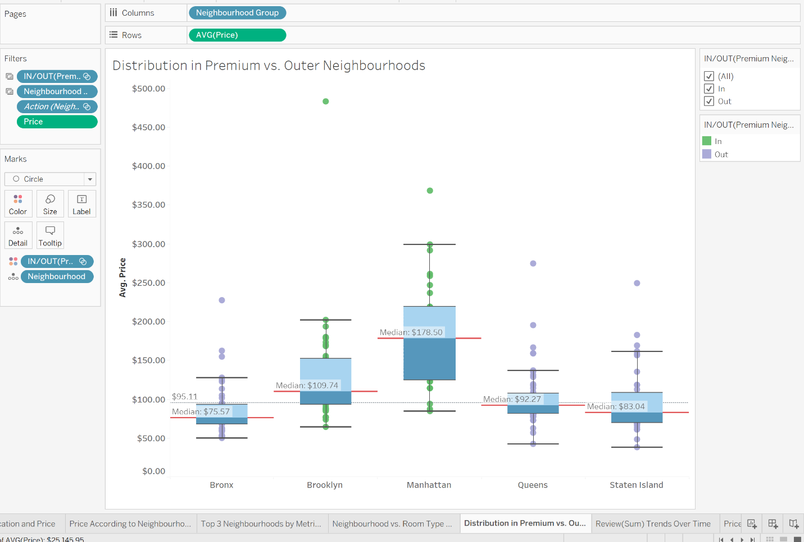

The fifth worksheet shows the distribution of prices across premium and outer neighbourhoods, with filters for neighbourhood groups and prices; highlighting median for each neighbourhood alongside the global median. This visualization revealed that premium areas such as Manhattan and Brooklyn consistently sit above the global median, while outer neighbourhoods like Bronx and Staten Island fall below, reinforcing the divide between luxury and budget. I created this view after earlier analyses showed strong variation in pricing by location and I wanted a clear way to compare neighbourhoods against both local and global benchmarks. It shows how median values provide a more stable measure than averages, reducing the impact of extreme outliers. A distribution chart with median lines was chosen because it clearly conveys the overall spread and allows easy comparison across groups. This analysis is meaningful because it highlights structural differences between premium vs. outer, showing how pricing patterns align with market segmentation and helping explain the dynamics of affordability versus luxury demand in NYC’s Airbnb market.

Sheet 6: Review Trends Over Time(Line Chart)

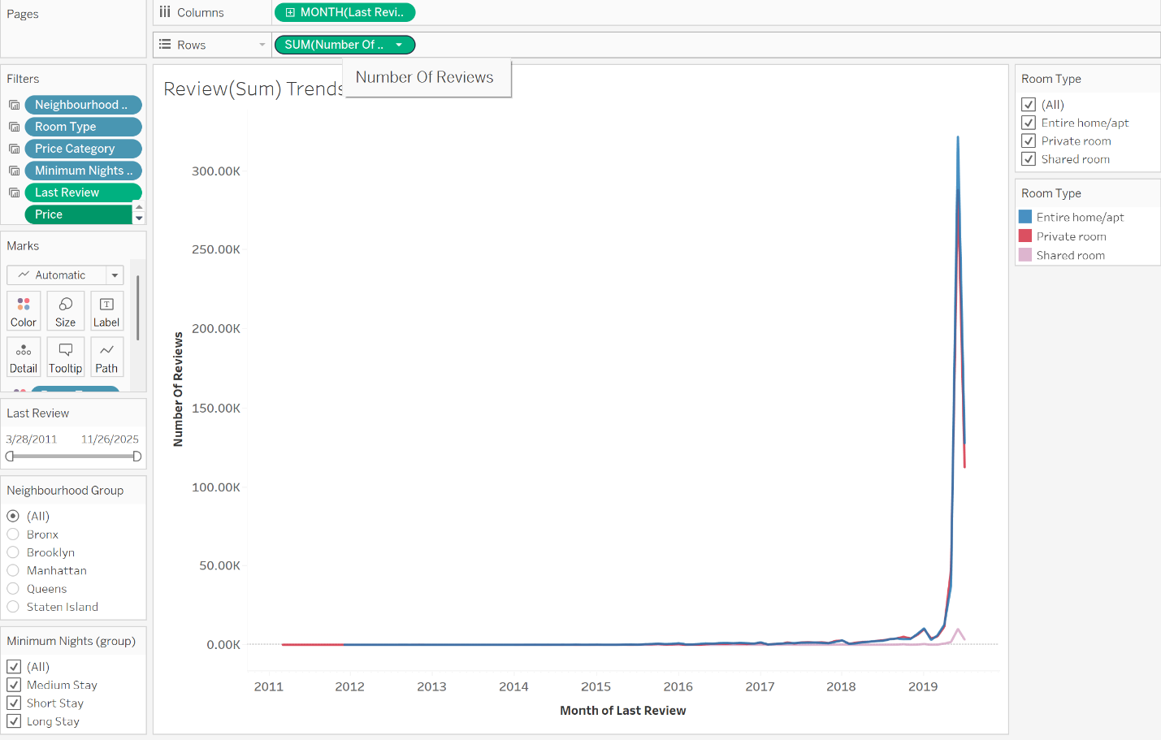

This worksheet shows review trends over time using the monthly sum of reviews for greater granularity, with filters for price category, minimum nights, last review, room type and a slider to adjust the date range. The visualization revealed that review activity increased steadily after late 2015, with premium listings and shorter minimum nights driving higher engagement, while longer stays and budget categories showed slower growth. I created this view after noticing that earlier review dates contained noise and wanted a clear timeline to track demand patterns. It shows how guest activity evolves over time, which is critical for understanding market momentum and seasonal shifts. A line chart is chosen because it is best to represent trends and changes across months, making patterns easy to interpret. This analysis is meaningful because it highlights how reviews reflect demand and satisfaction, helping explain the dynamics of growth in premium areas versus steadier activity in mid-market and budget segments.

Sheet 7: Price vs. Number of Reviews(Row level) by Minimum Night (Scatter Plot)

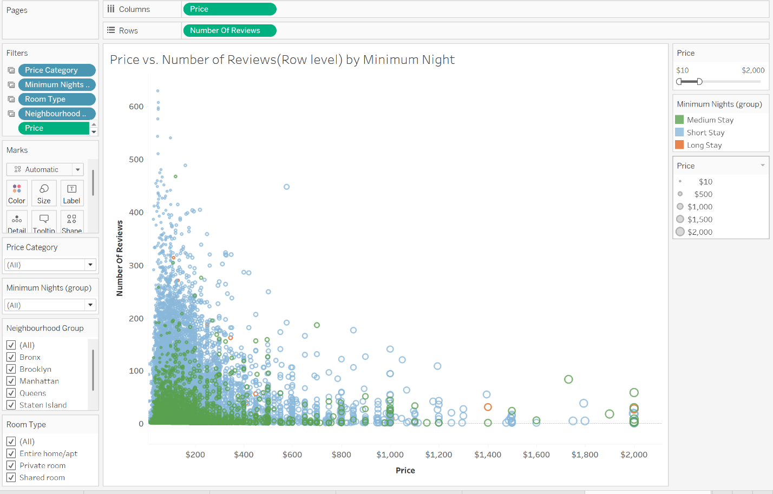

This worksheet plots price against the number of reviews at the row level, segmented by minimum night groups, with filters for price category, neighbourhood group and room type. The visualization revealed that listings with shorter minimum nights tend to attract more reviews even at higher price points, while longer minimum stays limit engagement despite occasional premium pricing. I created this view after earlier analysis showed that minimum night requirements strongly influence guest interaction and I wanted to see how they interact with price and reviews. Its relevance lies in connecting pricing strategy with customer engagement, which is critical for understanding demand patterns and host strategies. A scatter plot was chosen because it clearly shows the relationship between two continuous measures and highlights clusters and trends across categories. This analysis is meaningful because it demonstrates how price and minimum night policies jointly shape review activity, offering insights into both market demand and host strategies across different neighbourhoods and room types.

Part 3) Workbook Dashboards
Dashboard 1: Premium Neighborhood Pricing Insights

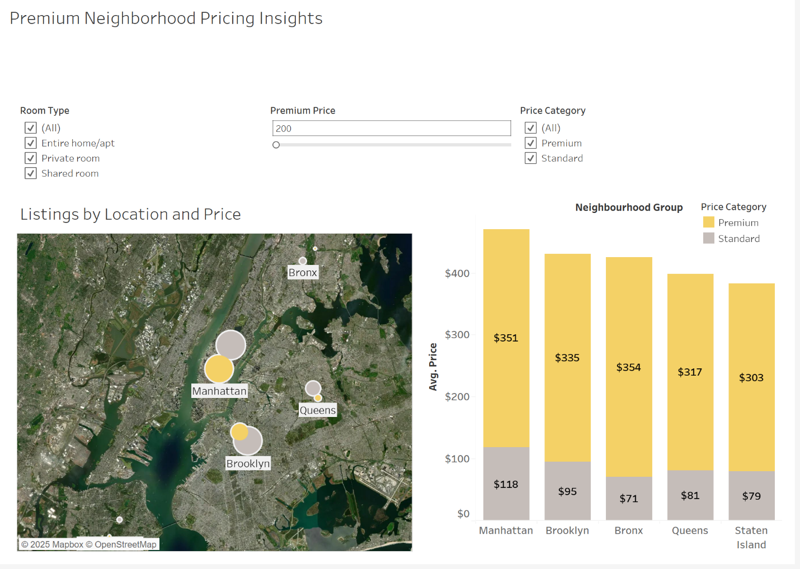

This dashboard combines two key components: a map showing listings by location and price, and a bar chart comparing average prices across neighbourhood groups. Interactive filters for room type, premium price range, and price category allow users to adjust the view and focus on specific market segments. I included these components because location and price are the strongest drivers of Airbnb demand and together they provide both spatial and comparative insights. The point of bringing these sheets together is to show how geography and pricing interact; where listings are concentrated, how premium areas differ from outer neighbourhoods and how room types influence the value. As a group, they give a clear overview of the NYC market structure, making the dashboard meaningful by allowing stakeholders to explore demand patterns dynamically and understand how different segments contribute to the overall market.

Dashboard 2: Pricing Intensity and Distribution- Premium vs. Outer

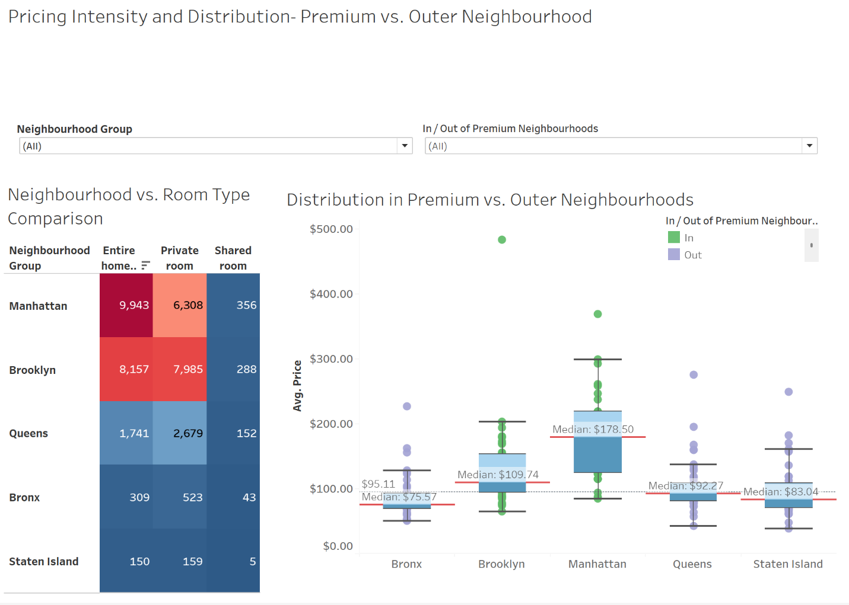

The second dashboard combines a heatmap and a box plot, with interactive filters for neighbourhood groups and premium vs. non-premium areas. The heatmap shows the intensity of listings across room types and neighbourhoods, while the box plot highlights the distribution of prices with clear median comparisons. Interactivity allows users to switch between premium and outer neighbourhoods to see how supply and pricing patterns shift. I included these components together because they complement each other: the heatmap reveals concentration and clustering of listings, while the box plot provides a statistical view of price spread and central tendency. As a group, they show both the structural distribution of listings and pricing dynamics across neighbourhoods, making the dashboard meaningful by connecting supply intensity with affordability and luxury segmentation in a single interactive view.

Dashboard 3: Reviews & Engagement by Price and Minimum Night

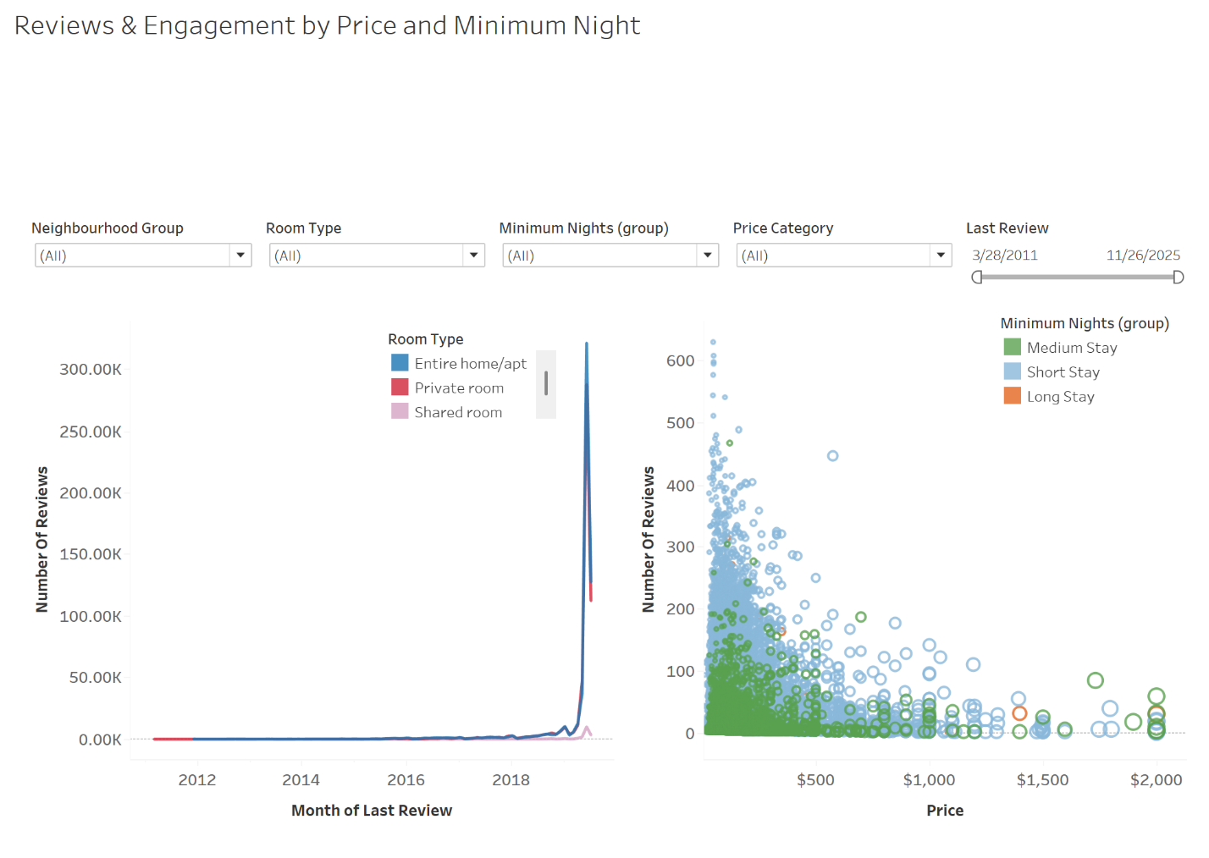

This dashboard combines a line chart and a scatter plot, with interactive filters for neighbourhood groups, room type, minimum nights, price category and last review. The line chart tracks review trends over time, while the scatter plot shows the relationship between price and number of reviews, allowing users to explore how engagement shifts across different segments. Interactivity lets users adjust filters to focus on specific neighbourhoods, room types or time ranges, making the analysis flexible and targeted. I included these components together because they complement each other: the line chart highlights overall demand trends, while the scatter plot reveals how pricing and minimum nights influence review activity. As a group, they show how demand evolves over time and how host strategies affect guest engagement. This makes the dashboard meaningful by connecting long-term trends with individual listing behavior, offering a deeper understanding of the NYC Airbnb market.

Part 4) The Story (Airbnb Market Dynamics in NYC)
Pane 1:
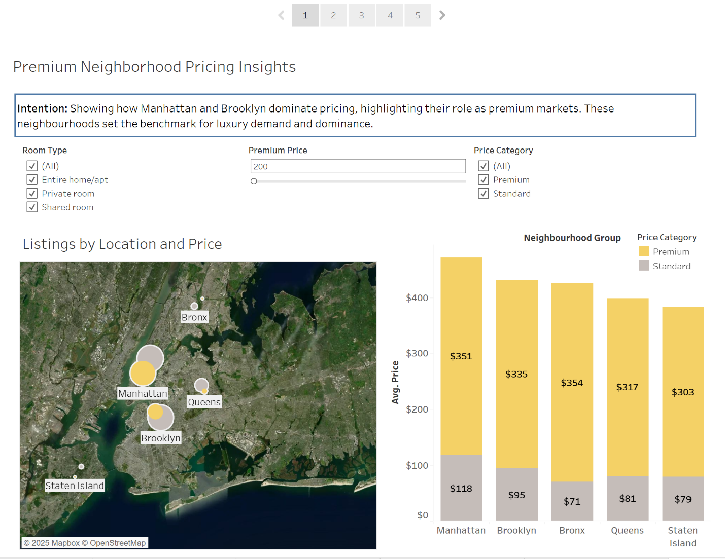
My analysis story begins by exploring Airbnb listings through individual worksheets and dashboards that progressively build insights. Pane 1 begins the analysis story by combining the map of listings by location and price with a bar chart of average prices across neighbourhood groups, both supported by interactive filters for room type, premium price range and price category. Together, these visuals establish the narrative that geography and pricing are the strongest drivers of Airbnb demand: the map reveals spatial clustering of listings, while the bar chart confirms systematic price differences across neighbourhoods. Manhattan and Brooklyn clearly dominate premium pricing, with most listings concentrated above $200; confirming their dominance in the Airbnb market. The points made here emphasize the divide between premium and budget markets, showing how luxury demand is concentrated in central neighbourhoods while outer neighbourhoods sustain affordability niches. Based on these insights, my recommendation is to optimize pricing strategies in premium areas to maximize profits, while leveraging outer neighbourhoods as competitive budget markets to expand reach and attract a wider customer base.

Pane 2:
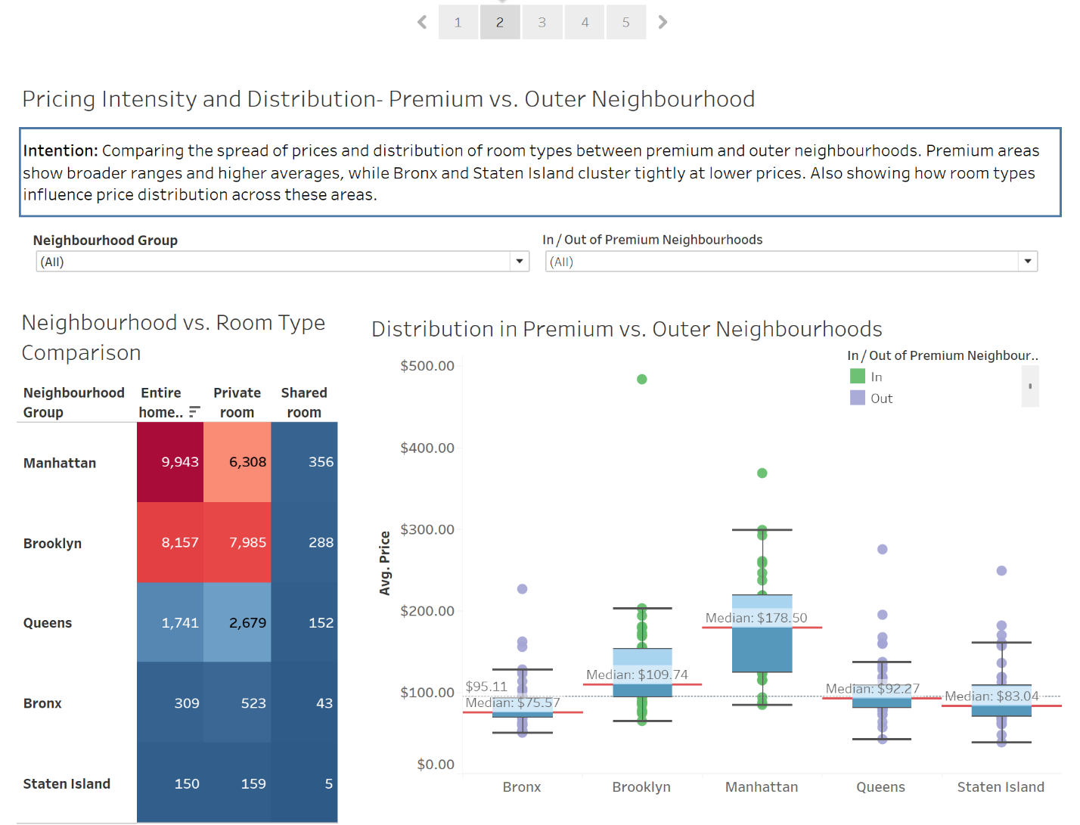
Pane 2 continues the analysis story by combining a heatmap of listing intensity with a box plot of price distributions, both filtered by neighbourhood group and premium versus non-premium areas. Together, these visuals show how supply and pricing interact. Heatmap highlights concentration of room types across boroughs, while box plot reveals median values and spreads. Manhattan and Brooklyn lead premium pricing, with higher medians and wider spreads that reflect both luxury and mid-range segments, while Bronx and Staten Island cluster tightly at lower ranges, signaling affordability and stability. Entire homes and private rooms in premium neighbourhoods drive higher averages, while shared rooms remain the budget option across all neighborhoods. The points made here emphasize the structural divide between premium and outer neighbourhoods, showing how room type and location jointly shape market positioning. Based on these insights, my recommendation is to strengthen premium offerings in Manhattan and Brooklyn to capture luxury demand, while promoting affordable shared and private room options in outer neighbourhoods to expand reach and maintain steady market reach.

Pane 3:
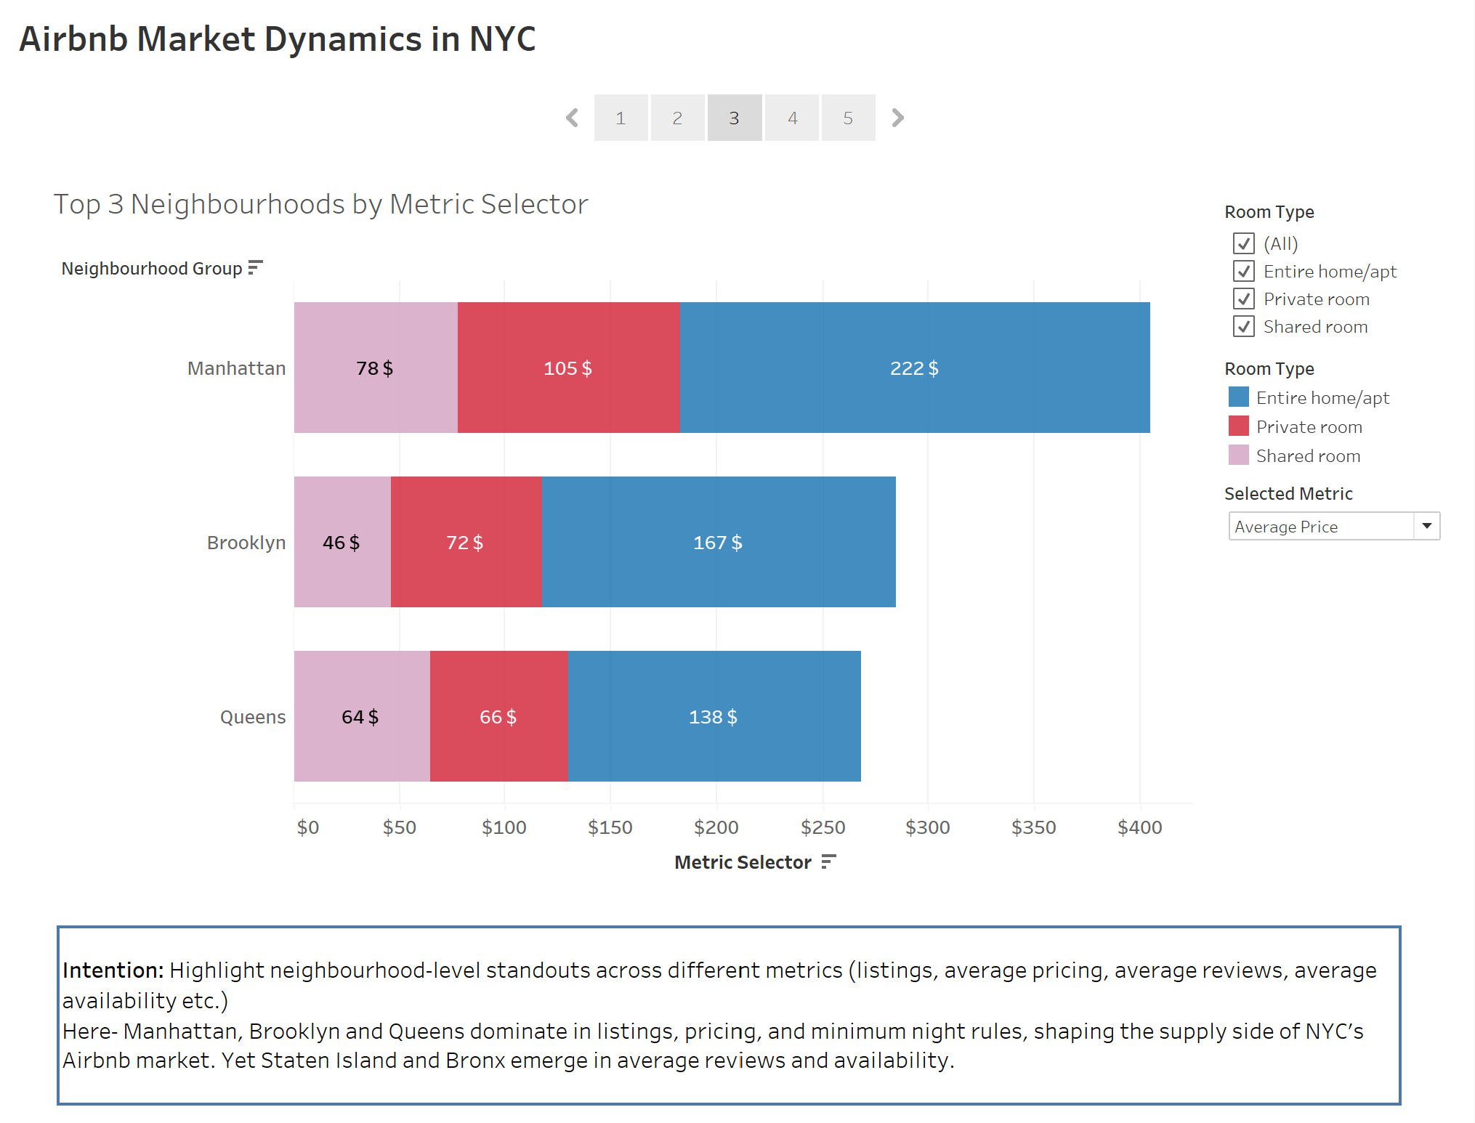
Pane 3 develops the analysis story through a horizontal stacked bar chart with a metric selector, allowing users to compare neighbourhoods across multiple measures such as listings, pricing, minimum night rules, reviews and availability. This interactive view reveals that Manhattan, Brooklyn and Queens dominate in listings, pricing, and minimum night rules, shaping the supply side of NYC’s Airbnb market. Yet Staten Island and Bronx emerge in average reviews and availability, showing that guest satisfaction and hosting consistency are not limited to only the largest neighbourhoods. Market dominance and guest engagement follow different geographic patterns, with Queens remaining consistent across every metric. The points made here emphasize that while premium neighbourhoods lead in supply and pricing power, outer neighbourhoods contribute significantly to guest satisfaction and reliability. Based on these insights, my recommendation is to continue strengthening premium strategies in Manhattan and Brooklyn to maximize profits, while leveraging Bronx and Staten Island as guest-friendly markets to improve satisfaction and diversify revenue streams.

Pane 4:
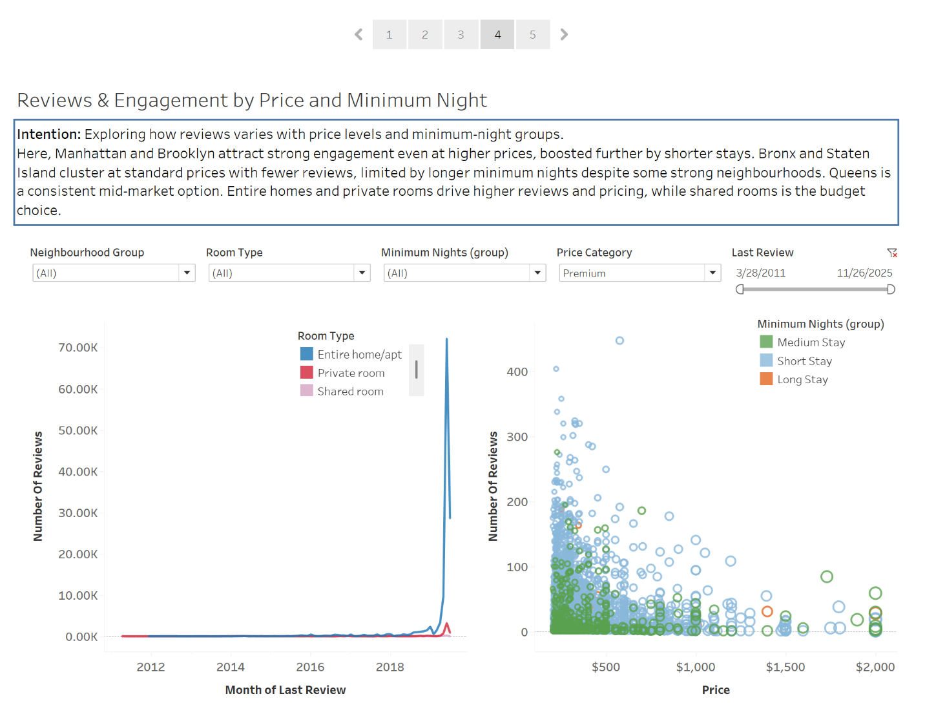
Pane 4 advances the analysis story by combining a line chart of review trends over time with a scatter plot showing the relationship between price and number of reviews, filtered by neighbourhood group, room type, minimum nights, price category and last review. This pane highlights how demand and engagement evolve both temporally and across pricing strategies. Premium neighbourhoods Manhattan and Brooklyn attract strong review activity even at higher price points, reflecting sustained demand for luxury stays, while shorter minimum nights further boost engagement. In contrast, Bronx and Staten Island cluster at standard prices with fewer total reviews, as longer minimum night requirements limit overall interaction despite some neighbourhoods performing well. Queens remain steady across all metrics, reinforcing its role as a consistent mid-market option. Entire homes and private rooms drive higher reviews and average prices, while shared rooms remain the budget choice across all. The points made here emphasize that premium neighbourhoods dominate luxury demand, outer neighbourhoods sustain affordability niches and room type policies directly influence guest engagement. Based on these insights, my recommendation is to optimize minimum night requirements in premium areas to sustain high review activity, expand mid-market offerings in Queens to capture consistent demand and leverage Bronx and Staten Island as reliable budget markets to improve satisfaction and broaden reach.
Pane 5:
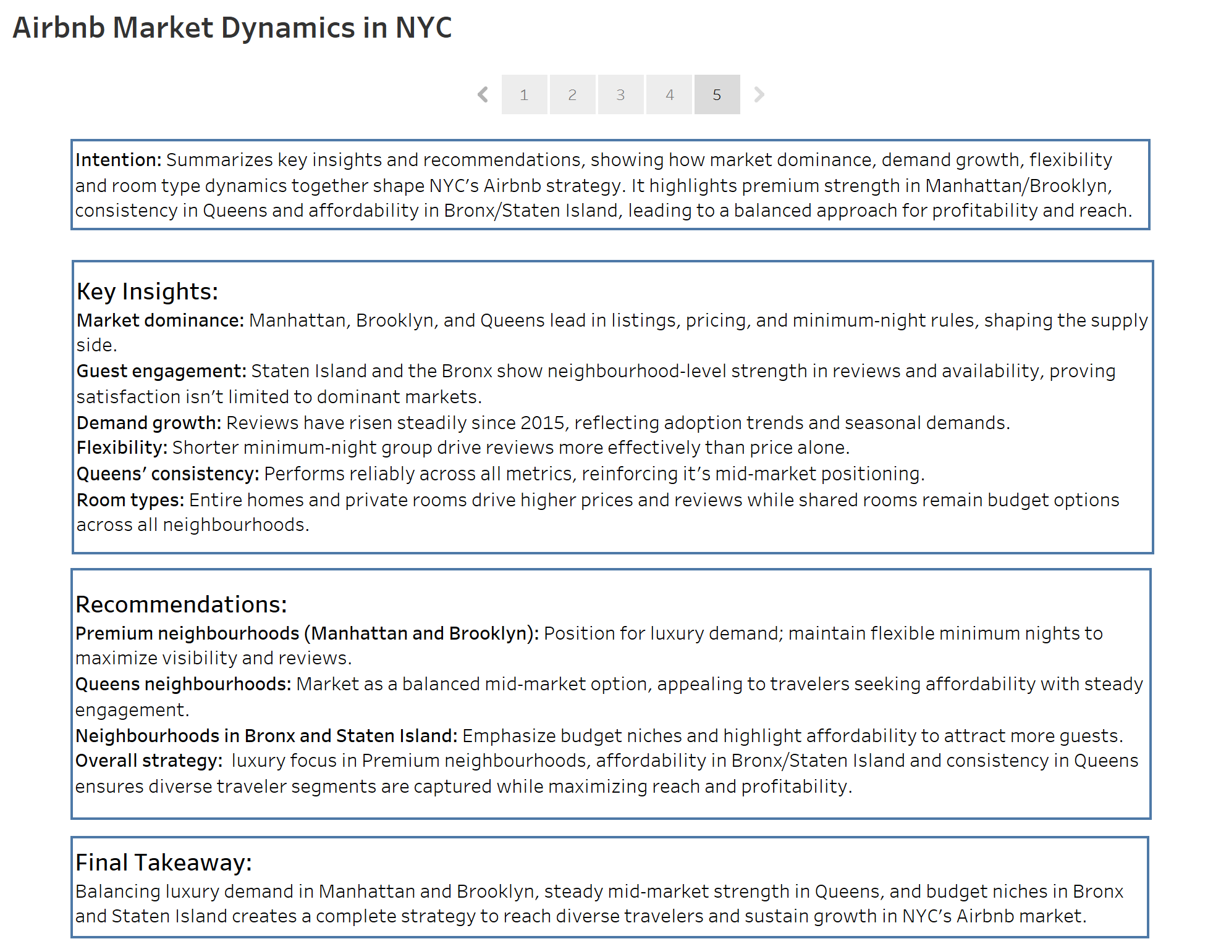
Pane 5 concludes the analysis story by summarizing the key insights drawn from the preceding worksheets and dashboards, tying together themes of market dominance, guest engagement, demand growth, flexibility, consistency and room type dynamics. The narrative shows that Manhattan, Brooklyn and Queens lead in listings, pricing and minimum night rules, shaping the supply side, while Staten Island and Bronx demonstrate strength in reviews and availability, proving satisfaction isn’t limited to dominant markets. Reviews have risen steadily since 2015, shorter minimum night rules drive engagement more effectively than price alone, Queens performs reliably across all metrics as a mid-market option and entire homes/private rooms drive higher averages while shared rooms remain the budget choice. These points emphasize that demand and satisfaction follow different geographic patterns, with premium neighbourhoods capturing luxury demand, Queens offering balanced consistency and outer neighbourhoods sustaining affordability niches. Based on these insights, my recommendations are to position Manhattan and Brooklyn for luxury stays with flexible minimum nights, market Queens as a steady mid-market option and highlight affordability in Bronx and Staten Island by reducing minimum nights to attract more guests. The overall strategy balances luxury, mid-market and budget segments; ensuring diverse traveler needs are met while maximizing reach, profitability and sustainable growth in NYC’s Airbnb market.

Part 5) Conclusions
Through this course and project, I learned how to use Tableau not just as a visualization tool, but as a platform for building interactive, insightful stories that support business decisions. I developed skills in creating visualizations with filters, parameters, groups and sets, and learned how to connect them through dashboard actions to make the analysis dynamic and user-driven. I learned how to leverage calculated fields, level of detail expressions and aggregations to transform raw data into meaningful granular insights. I also gained experience in designing dashboards that flow into cohesive stories, allowing users to explore data from multiple perspectives and uncover actionable insights. One obstacle I faced was Tableau desktop’s limited data cleaning capabilities, which made it challenging to stabilize the dataset; I overcame this by combining Tableau with Excel and Power BI to identify and resolve data issues before linking everything back into Tableau. I also initially struggled with dashboard actions, but through practice I’m gradually mastering them, enabling me to build dashboards that are both interactive and meaningful. Overall, this experience taught me how to transform raw data into clear, engaging narratives that guide strategic decisions. And the most rewarding part is seeing the visualization not only match what I first imagined, but become even more granular, interactive and insightful; delivering exactly the story I wanted to bring to life.

